**Results of Crowbar Test – Raw Data**

June 16, 2017

These results are raw data, with no subtracted reference. Completed June 16, 2017, for MOSES III. Measurements shown are an average of 32 single interferogram measurements using 4Sight software. Zernike values are taken from the in-program Zernike polynomial worksheet. For use in comparing placement of the mirror to overall mirror surface aberrations, in order to prepare to correct mirror figure. Definitions for each of the tests can be found on page 13 of this document.

**Pre-Crowbar**

|  |  |
| --- | --- |
| -0.0076 | Piston or Bias |
| -0.0072 | Tilt X |
| -0.0334 | Tilt Y |
| -0.0287 | Power |
| 0.0480 | Astig X |
| -0.15661 | Astig Y |
| 0.0310 | Coma X |
| -0.19751 | Coma Y |
| -0.0017 | Primary Spherical |
| 0.0267 | Trefoil X |
| 0.0669 | Trefoil Y |
| -0.0681 | Secondary Astig X |
| 0.0605 | Secondary Astig Y |
| -0.0477 | Secondary Coma X |
| -0.0102 | Secondary Coma Y |
| 0.0509 | Secondary Spherical |
| 0.0658 | Tetrafoil X |
| 0.0333 | Tetrafoil Y |

**Pitch Plus**

|  |  |
| --- | --- |
| -0.13843 | Piston or Bias |
| 0.68788 | Tilt X |
| 3.857 | Tilt Y |
| -0.32544 | Power |
| 0.82796 | Astig X |
| -0.42205 | Astig Y |
| -0.51327 | Coma X |
| -1.251 | Coma Y |
| -0.18987 | Primary Spherical |
| -0.0890 | Trefoil X |
| 1.146 | Trefoil Y |
| 0.74123 | Secondary Astig X |
| 0.0619 | Secondary Astig Y |
| -0.26687 | Secondary Coma X |
| -0.50561 | Secondary Coma Y |
| -0.0088 | Secondary Spherical |
| -0.27150 | Tetrafoil X |
| -0.35838 | Tetrafoil Y |

**Pitch Minus**

|  |  |
| --- | --- |
| 0.15076 | Piston or Bias |
| -0.14187 | Tilt X |
| 0.72882 | Tilt Y |
| 0.33033 | Power |
| -0.24233 | Astig X |
| 0.15341 | Astig Y |
| 0.10866 | Coma X |
| 0.96371 | Coma Y |
| 0.17278 | Primary Spherical |
| -0.37298 | Trefoil X |
| -1.191 | Trefoil Y |
| -0.64517 | Secondary Astig X |
| -0.0010 | Secondary Astig Y |
| 0.0447 | Secondary Coma X |
| 0.53232 | Secondary Coma Y |
| 0.0402 | Secondary Spherical |
| 0.44654 | Tetrafoil X |
| 0.37508 | Tetrafoil Y |

**Push Up**

|  |  |
| --- | --- |
| 0.0940 | Piston or Bias |
| 0.16052 | Tilt X |
| -1.290 | Tilt Y |
| 0.20166 | Power |
| 0.0692 | Astig X |
| 0.0286 | Astig Y |
| -0.0494 | Coma X |
| 0.47209 | Coma Y |
| 0.10397 | Primary Spherical |
| -0.18565 | Trefoil X |
| -0.55239 | Trefoil Y |
| -0.29258 | Secondary Astig X |
| 0.0449 | Secondary Astig Y |
| -0.0419 | Secondary Coma X |
| 0.30088 | Secondary Coma Y |
| -0.0013 | Secondary Spherical |
| 0.26938 | Tetrafoil X |
| 0.12011 | Tetrafoil Y |

**Push Down**

|  |  |
| --- | --- |
| 0.12549 | Piston or Bias |
| -0.76507 | Tilt X |
| -2.402 | Tilt Y |
| 0.26896 | Power |
| -0.23406 | Astig X |
| 0.13846 | Astig Y |
| 0.13032 | Coma X |
| 0.84702 | Coma Y |
| 0.13747 | Primary Spherical |
| -0.32652 | Trefoil X |
| -1.037 | Trefoil Y |
| -0.59527 | Secondary Astig X |
| 0.0004 | Secondary Astig Y |
| 0.0442 | Secondary Coma X |
| 0.48776 | Secondary Coma Y |
| 0.0312 | Secondary Spherical |
| 0.40386 | Tetrafoil X |
| 0.28174 | Tetrafoil Y |

**Push Y+ Direction**

|  |  |
| --- | --- |
| 0.0082 | Piston or Bias |
| 0.50754 | Tilt X |
| -0.0133 | Tilt Y |
| 0.0107 | Power |
| 0.20589 | Astig X |
| -0.0794 | Astig Y |
| -0.0859 | Coma X |
| -0.0380 | Coma Y |
| 0.0322 | Primary Spherical |
| -0.0220 | Trefoil X |
| -1.484E-05 | Trefoil Y |
| -0.17635 | Secondary Astig X |
| 0.0430 | Secondary Astig Y |
| -0.0756 | Secondary Coma X |
| 0.0510 | Secondary Coma Y |
| 0.0132 | Secondary Spherical |
| 0.0232 | Tetrafoil X |
| 0.0040 | Tetrafoil Y |

**Push Y- Direction**

|  |  |
| --- | --- |
| -0.0266 | Piston or Bias |
| 0.47240 | Tilt X |
| 0.70438 | Tilt Y |
| -0.0748 | Power |
| 0.18249 | Astig X |
| -0.0495 | Astig Y |
| -0.14993 | Coma X |
| -0.29361 | Coma Y |
| -0.0251 | Primary Spherical |
| 0.0100 | Trefoil X |
| 0.24156 | Trefoil Y |
| -0.0599 | Secondary Astig X |
| 0.0060 | Secondary Astig Y |
| -0.11238 | Secondary Coma X |
| -0.0653 | Secondary Coma Y |
| 0.0134 | Secondary Spherical |
| -0.0033 | Tetrafoil X |
| -0.0840 | Tetrafoil Y |

**Pounding**

|  |  |
| --- | --- |
| -0.0060 | Piston or Bias |
| 0.0855 | Tilt X |
| -0.0539 | Tilt Y |
| -0.0299 | Power |
| 0.10046 | Astig X |
| -0.0449 | Astig Y |
| 0.0191 | Coma X |
| 0.0379 | Coma Y |
| 0.0171 | Primary Spherical |
| 0.0424 | Trefoil X |
| -0.14400 | Trefoil Y |
| -0.16485 | Secondary Astig X |
| 0.0396 | Secondary Astig Y |
| -0.0544 | Secondary Coma X |
| 0.10434 | Secondary Coma Y |
| 0.0337 | Secondary Spherical |
| 0.0523 | Tetrafoil X |
| 0.0307 | Tetrafoil Y |

**Charts of Individual Tests with Corresponding Low Order Zernikes**

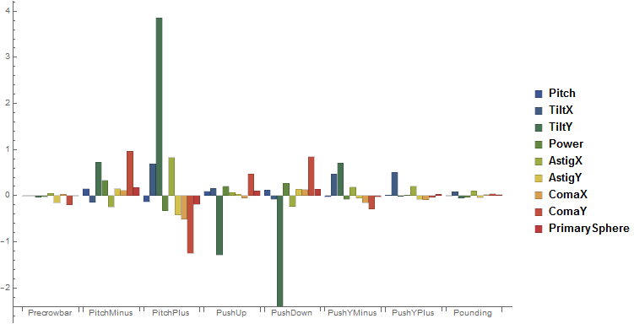

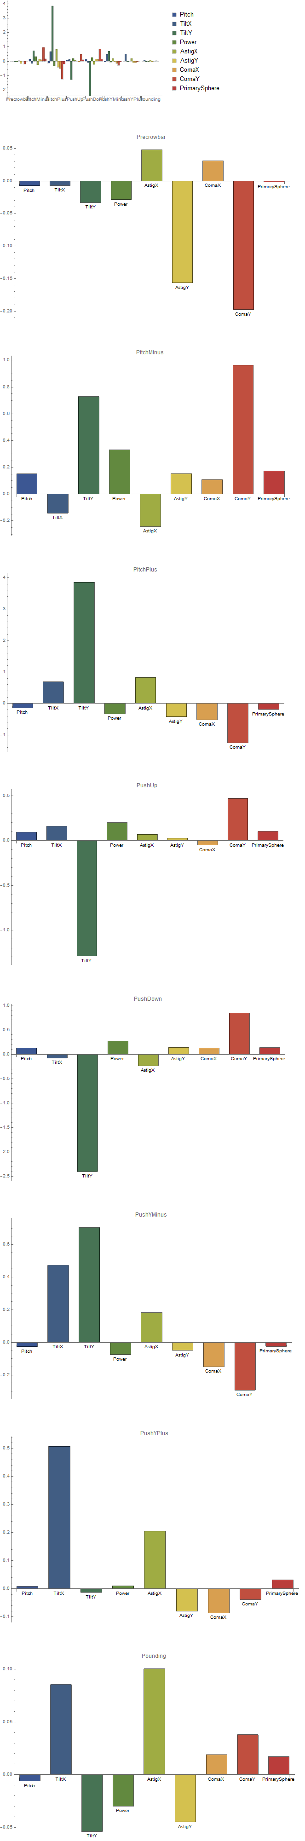

  


  
**Charts of Individual Zernikes for Each Test**

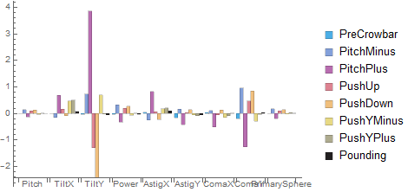

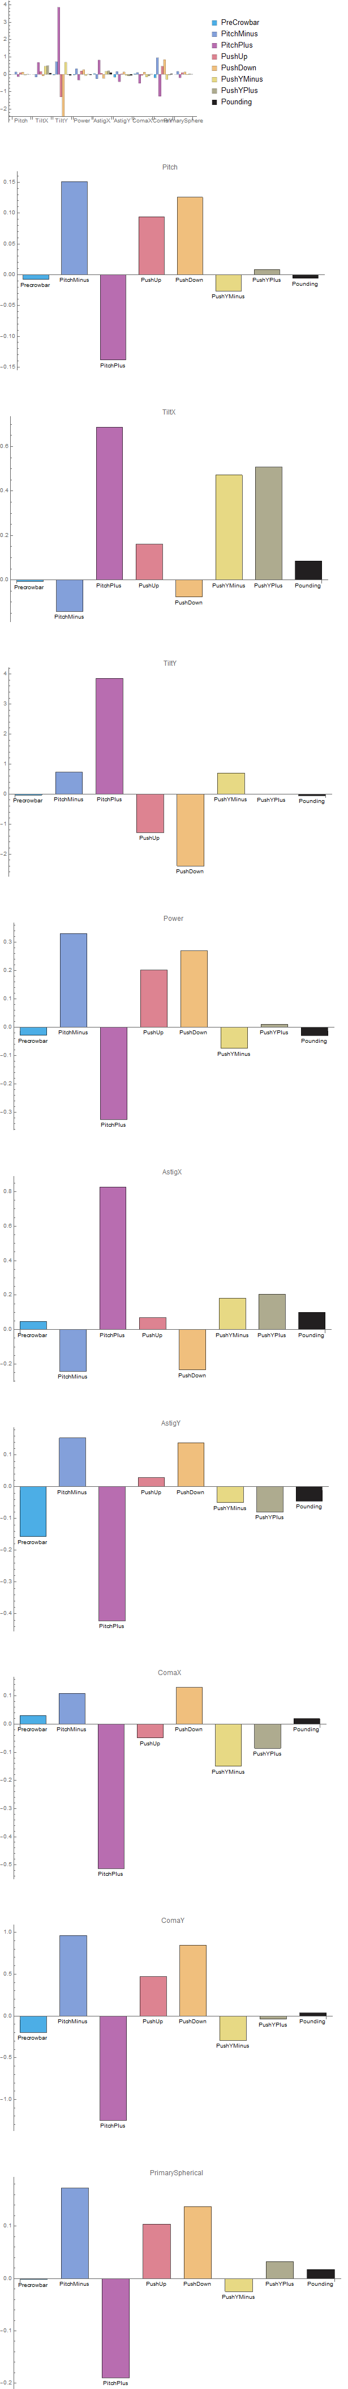









**Pre-Crowbar**

The mirror before any adjustments were made.

**Pitch Plus**

Movement of the mirror such that it is tilted in the plus direction.

**Pitch Minus**

Movement of the mirror such that it is tilted in the minus direction.

**Push Up**

A shift of the mirror upwards from center in the mount.

**Push Down**

A shift of the mirror downwards from center in the mount.

**Push Y+**

A shift of the mirror in the Y+ direction according to MOSES coordinates.

**Push Y-**

A shift in the mirror in the Y- direction in the mirror mount.

**Pounding**

Shifting of the mirror in various directions with the purpose to settle it into a position of least tension, and therefore, lowest energy.